Adult & Higher Education Division

EXECUTIVE DIRECTOR OF ADULT & HIGHER EDUCATION: Denise Bill, Ed.D
MUCKLESHOOT TRIBAL COLLEGE ADMINISTRATOR: Madrienne White
ANNUAL REPORT SUBMISSION: Michelle Williams, Analyst & Researcher
LOCATION: 39811 Auburn Enumclaw Rd. SE, Auburn, WA 98092
PHONE: (253)876-3345
EMAIL: Denise.Bill@Muckleshoot.nsn.us

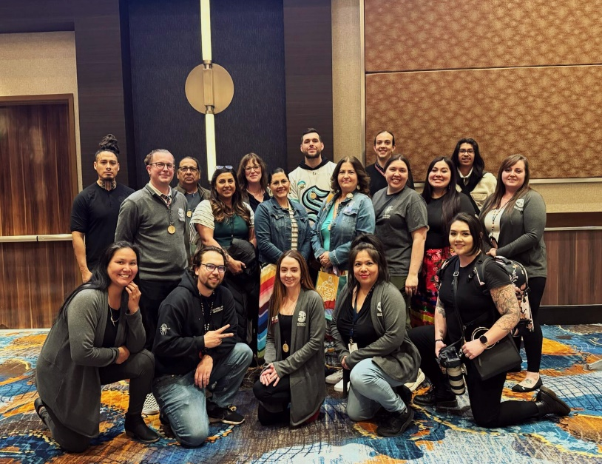
The Adult and Higher Education Division of the
Muckleshoot Department of Education consists
of the following programs:

- College and Career Education Opportunities
(CCEOP)
- Financial Aid & MIT Scholarship Dept.
- Workshops & Training
- Muckleshoot Tribal College
- GED and High School 21+
- Native American Career and Technical
Education Programs
- College & University Partnerships

Mission Statement

“The Muckleshoot Tribal College is a Tribally directed education leader, promoting lifelong learning and the power to choose. Through strategic partnerships, we create a culturally inspiring environment that expands academic and career opportunities for our immediate Tribal family and extended Community.”

Community Engagement

The Muckleshoot Tribal College endeavors to engage with our tribal members and local community. We also strive to network with our broader tribal and academic counterparts. This year our team members presented at the National Indian Education Association (NIEA) conference in Palm Springs CA. Dr. Denise Bill, Justine Koble, and Justice Bill shared about MTC history, programming, and our approach to integrating Indigenous and Muckleshoot forward praxis and pedagogy throughout our spaces and offerings. Connections and lessons were embraced and shared throughout the conference which will manifest in benefits for our students and our community. These exercises in relationship-building and knowledge-gathering, build strong academic and professional networks that bear fruit for our students and staff.
Additionally, our staff and leadership have accepted numerous invitations for partnership and engagement by local colleges and Universities. We welcomed visitors from WSU, and Shoreline Community College; we also traveled to Pierce and North Seattle Colleges. All in the spirit of cultivating relationships with these institutions, sharing context about our placed-based educational opportunities, and discussing collaborative innovations that we intend to build and offer to our students at MTC, but delivered through an Indigenous lens and on Tribal Sovereign ground.
On the local front, MTC team members endeavor to continue to offer placed-based education that benefits and engages our Tribal and community membership. We survey our students every quarter to ensure our offerings are relevant and respectful of students’ time, professional, and personal goals and aspirations. Additionally, MTC staff continually engage with our Muckleshoot membership and community by attending public gatherings, Tribal events, school recruitment activities, and cultural events. For example: Tabling at Tomananus Day, the Veteran’s resource fair, our annual Career Day and even at the Washington State Fair.
We also regularly interact and collaborate with our local schools and Muckleshoot Educational affiliates such as Muckleshoot Tribal School and the Auburn School District. For example, our Tribal College Administrator, Madrienne White, continues to guest lecture at Auburn Riverside High School to share information on Muckleshoot Tribal history, government structure, and cultural identity. This helps to shed light on the significance of Tribal sovereignty in our region, state, and nation. She also shares about Tribal reciprocal relationships that our people have with land, our natural resources/ environment, and our non-human relatives. These engagement efforts help to increase the visibility of our tribe and encourages our non-Native neighbors to understand and appreciate the contributions of our tribe and their political, legal, and governmental status.
Denise Bill and Madrienne White continue to oversee several MOU’s (Memorandum of Understanding’s) with several of our partners such as Green River College, Renton Technical College, Northwest Indian College, and University of Washington, Tacoma. Denise Bill also serves on the Washington State Board of Community and Technical Colleges, and attends quarterly meetings.

Partnerships

As suggested in our Mission Statement, partnerships are integral to the Muckleshoot Tribal College. Although MTC offers our own and industry standard certificates, as a non-accredited institution we rely on our partner institutions to help offer our students degrees and High School Diplomas. However, while initiating partnerships, it is important for us to convey the importance and significance of respecting our students’ identity and connecting the academic content to our students in meaningful ways. We at MTC acknowledge and celebrate our students’ cultural and tribal identity, we endeavor to ensure that any offerings at the Tribal College are delivered through an Indigenous lens and that materials and content are culturally relevant and responsive.

Programming Expansion

MTC continues to deliver CTE classes in Microsoft Office (beginner, intermediate, and advanced), and Audio and Film Making Foundations, while also offering classes from Northwest Indian College, the University of Washington Tacoma, Pre-Apprentice Carpentry with Green River College, and Certified Nursing Testing. However, over the last several years, our MTC leadership, Green River College, and the Early Childhood Development programs have been meeting and discussing bringing ‘Place-Based Education” back to MTC for our ECE staff and students. The Pre-Apprentice Carpentry Program, through its nine cohorts and 67 participants, has established a comprehensive training framework in key construction areas including Basic Woodworking (Indus 101), Stair Construction (Carp 162), and an Introduction to Construction Trades such as electrical, plumbing, and carpentry. Originating at Bates Technical College, the program now partners with Green River College, where 7 students, including 4 Muckleshoot tribal members are currently over halfway through the 2024 Fall Cohort. The Tribal College underwrites tuition, a $300 work gear voucher, and all required tools for participants, plus a $500 mid-quarter incentive and an additional $500 upon completion for Muckleshoot enrolled individuals, emphasizing the program's dedication to comprehensive support and education.

Pre-Apprentice Carpentry & Certified Nursing Assistant (CNA) Program- Justice Bill

This Summer, 11 students successfully completed Indus 108: "Intro to the Construction Trades" (Summer, 2024), where they learned basic electrical concepts, introductory plumbing, dry walling, residential and commercial carpentry. This program is ideal for homeowners or those interested in a degree or career in construction. Moreover, each quarter the class does a community project as a "giveback." This summer’s community project was the construction of a concrete fish pit in the backyard of the Muckleshoot Tribal College, an accomplishment that ensures our first foods have a place at the college. These skills will culminate in college credits applicable to an AA in Carpentry Technology, and a Certificate in Carpentry Technology, leading to a seamless pathway into the trades.
The Certified Nursing Assistant (CNA) Program is a collaborative effort between Muckleshoot Elders In-Home Support Services (MEIHSS), the Muckleshoot Tribal College (MTC), and MTC’s partner institutions Renton Technical College (RTC) and Green River College (GRC). Since the program’s inception in Winter of 2020, there have been 8 cohorts, 7 with RTC and 1 with GRC, and 43 total graduates.

Participants in the Muckleshoot Tribal College CNA Program’s Winter Cohort 2024 complete a 5-week, 5 credit course that prepares them for the Washington State Nursing Assistant Certification Exam. The first 3 weeks consisted of the 3 credit course NA 101, Fundamentals/Skills for Nursing Assistant. Students received instruction on the RTC Campus by Professor Jean Burdick Mondays-Thursdays from 9:00AM-1:30PM, with a Student Support Day in person at MTC on Fridays. Our students finish with the 2 credit course NA 131, a clinical practicum held at RTC’s partner Kline Galland Home, a long-term care facility in South Seattle. The Muckleshoot Tribal College provides transportation to both RTC and the clinical site, and some of the most endearing feedback received from the students is that while they appreciated the opportunity, they were excited to finish the program and return to caring for our community’s elders. Between the Winter and Spring cohorts held in 2024, 11 students successfully completed the program, including 3 tribal members.

Muckleshoot Tribal College Digital Library Creation
The Muckleshoot Tribal College is proud to continue developing its digital library, a dynamic resource for students and the entire Muckleshoot community. This library brings to life a long-held vision of Dr. Willard Bill Senior to establish a dedicated space where Muckleshoot culture, knowledge, and traditions can be honored and shared. Led by Adult and Higher Education Executive Director- Dr. Denise Bill, Project Manager- Wayne Buchanan, and Analyst & Researcher- Michelle Williams, this project is the product of months of thoughtful planning and collaboration, with crucial support from our IT team to configure the best platform to serve MTC’s unique needs. To begin, we selected Kotobee as a secure and accessible home for our current submissions, housing a diverse range of culturally significant works and documents, all available to be read on the platforms seamless digital reader. Kotobee has provided a valuable foundation for preserving and sharing Muckleshoot Tribe materials during our interim phase while awaiting our upcoming partnership with Washington State University. Looking ahead, we are excited to join forces with Washington State University to transition our digital library onto Mukurtu, a Native-centered platform created with Tribal sovereignty in mind. Mukurtu’s design empowers students and the wider community to explore, celebrate, and preserve Muckleshoot culture, traditions, and creative expressions, supported by a dedicated team that ensures the sovereignty and integrity of each submission. Through Mukurtu, we will offer access to a rich collection of resources that honor and document Muckleshoot heritage. Our library is further enhanced by our partnerships with JSTOR and GALE, making extensive research resources available directly through our website, MTCollege.org. With each step, we are committed to making Dr. Bill, Sr’s vision a reality, establishing this digital library as a vital resource for education, cultural connection, and community pride.
Muckleshoot Tribal College Website

Michelle Williams, Muckleshoot Tribal College Analyst & Researcher while also incorporating valuable input from Olivia Courville, CTE Instructional Coordinator, and Madrienne White, Tribal College Administrator has been instrumental in transforming Muckleshoot Tribal College’s digital presence with her work on MTCollege.org,. MTC’s revamped website serves as a vital resource, offering access to academic materials, community events, and cultural initiatives, including the expanding digital library. Since its launch, MTCollege.org has generated numerous inquiries from students and serve as an intake platform that has led to several exciting partnership opportunities. Maintaining the website herself, Michelle ensures it remains an accessible, up-to-date platform that reflects the college’s dedication to education and cultural preservation, while fostering valuable connections across communities.

Outlook for the Coming Year

Our team plans to continue to support and advocate for a new Adult and Higher Education building. After a lull during the pandemic, we’ve seen a resurgence of tribal and community members’ eager to return or embark on their adult and higher education journeys. With a new building, we hope to accommodate more students, address logistical needs, and expand programming that aligns with students’ broadening interests. For example, we would love to offer a broader variety of certificate and degree opportunities, such as hospitality training/education, continued professional development education, IT/cyber-security-related certifications, business management education, culinary arts, and much more. We also dream of creating a space where working parents feel acknowledged and supported and offer a supervised child friendly area. As we believe in intergenerational learning opportunities, this space would honor elders and encourage cultural learning opportunities such as Storytelling.
We also endeavor to maintain and cultivate relations with our academic, tribal, and community partners, and allies. By this, we mean to preserve and strengthen our current partnerships and seek to bridge communication to leverage educational opportunities with new and additional networks and institutions. We also plan on continuing our work with community engagement and continue to strive to be better every day. Our goal is to provide the tribe, community, and students with quality experiences through culturally relevant land-based education. We do this while holding cultural teachings close to our hearts. As our Project Manager, Wayne Buchanan, shared with us: Be Kind, be helpful, be sharing- The late Gilbert King George.

tə sc̓aliʔčəł gʷələ swələx̌ʷ dxʷʔal syayusčəł
(Our hearts are strong towards our work)

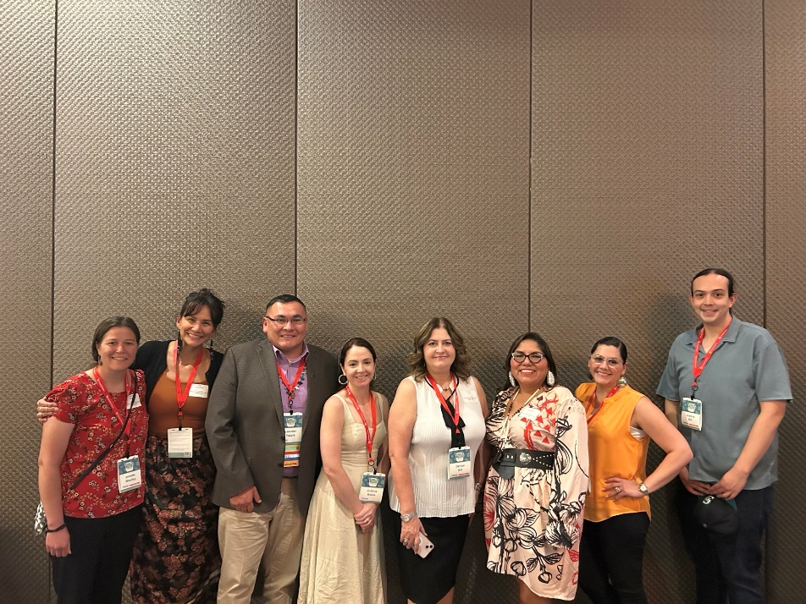

College & Career Education Opportunity Program (CCEOP)

PROGRAM MANAGER: Michele Rodarte
LOCATION: Muckleshoot Tribal School Building C 38723 172nd Ave SE Auburn, WA 98092
PHONE: (253)876-3291
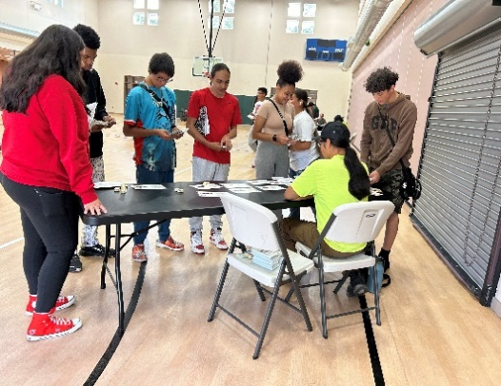
EMAIL: CCEOP@Muckleshoot.nsn.us

Mission Statement

The mission of the Muckleshoot College & Career Education
Opportunities Program is to introduce Muckleshoot youth,
ages 14 to 18 years old, to college and career information.
Both academic training and practical experience will assist
them in making informed decisions and taking the necessary
action when choosing a career path. Careers within
Muckleshoot Tribal enterprises will be the primary focus,
but participants will have the opportunity to explore any
career field in which they have an interest.

Program Description

The College and Career Education Opportunities Program is a career exploration program that enables Muckleshoot enrolled youth to explore careers in a variety of professions and businesses. Through these experiences, youth gain the knowledge and confidence necessary for making future career and education decisions. The program involves many aspects, all designed to educate students in their career direction and choices.

Services Provided

- Opportunities to Develop Job Skills
- Career Preparation
- MIT Career Day
- Internships
- Career and Job Shadowing
- Work Ethics

Educational Conferences/Workshops

- January 8th Muckleshoot Scholarship Student Information and Program Services: 18 youth attended.
- January 18th Career Pathways Auburn Andy Torres, MTS Summer Shelton, Justice Bill-MTC Pre Apprentice Program and ECE Information.
- April 22nd - Narcan training with MBHP- Lucille Martin.
- August 2nd Financial Literacy – Spending Frenzy Workshop and Cultural workshop with Morgan SoHappy, and Noreen Milne making mini drums and rattles.
- Soft Skills Training on October 29th with Kelly Griffin & Janet LaClair MIT Training and Development.
- Conducted mock-up interviews Sept 17th – 20th and hired 70 youth for the 2024/2025 School Session which began on October 15th, 2024
- November 12th Hermanson Trades Workshop at CCEOP Building D.
- November 19th Auburn Aviation Workshop at CCEOP Building D.

Off Site Field Trips

- March 25th GRC Trades Field Trip – 21 youth attended;
- July 11th Puget Sound Skills Center
- July 18th Emerald Downs
- August 1st GRC Pre Apprentice Tour: Welding, Automotive, MTC Pre Apprentice Program.
Cultural Activities

- August 2nd - Mini Drums w/Noreen Milne, Hyde Rattles w/Morgan SoHappy
- October 19th- MTS Culture Night 7 youth participated;
- March 21st Culture Night @MTS: 9 youth attended;
- April 22nd Cultural workshop making possible Cooking Salt Combinations w/Rachel Heaton.

MTC Cedar Tree Native Leadership Program: Some youth attended once a month.

- October – Employability, Hospitality, Financial Literacy.
- November– Environmental Science
- December – Indigenous Entrepreneurship
- January – Health and Wellness
- March – Community Service
- April – Traditional Plants
- May – Tribal History and Culture Preservation.

Staff Trainings and participation w/AHE events etc.

- February 2nd – Hired on 13 more youth and held orientation on February 20th.
- February 22nd Ever safe Training for the CCEOP Staff via. ZOOM.
- April 1st – April 30th Advertised for CCEOP 2024 Summer Session.
- April 11th 2024 Brought on 4 youth to fill the vacant positions.
- April 30th Muckleshoot Career Day @ Muckleshoot Casino.
- May 20th MTC/AHE Professional Development
- May 30th 2023/2024 School Session Ended.
- June 13th & 14th CCEOP Staff Training: 13th Ever safe, First Aid/CPR and Blood Borne Pathogens. Mandated Reporting 14th w/Mahogany Sexton and Laurel Kelly, from MCFS.
- June 17th C.C.E.O.P Staff attended the Be the Change Training: with the Muckleshoot Youth Development Program.
- June 20th C.C.E.O.P Self Care Training with Rachel Heaton.
- Advertisement for the 2024/2025 School Session began August 12 and ran through Sept 16th to hire on 50 youth.
- Extended job postings Sept. 16th – Sept 29th and were approved by Exec. Ed. to hire on a total of 70 youth for the 2024/2025 School Session.
- Hired 1 seasonal transporter for the 23/24 school session and 3 for summer session.

Retention Rate

Of the 100 Youth Participants hired, 98 completed the program for 2024 Summer Session. The retention rate was 98% of the 100 participants who completed the Summer Program.
Of the 55 Youth Participants hired, 46 actively participating within the School Session October 16, 2023 through May 30, 2024. The retention rate was 83.64% of the 55 participants currently active within the School Session Program.

Worksite Placement and Number of Youth Participants Placed:
Job Placement Sites | Sum | School
Muckleshoot Child Development Center/Tribal School | 3 | 4
Youth Development Center/YDP MCDC | 6 | 5
Equine Program | 9 | 2
Pentecostal Church
Information Technology | 5 | 4
Tribal Council Chambers
Wildlife Preservation
Culture Program/Canoe Club | 7 | 1
Resource Center | 4 | 2
General Services | 4
Health and Wellness Center | 2 | 3
Elders Complex Culture w/Gail WhiteEagle | 3 | 1
Muckleshoot Early Learning Academy | 2 | 2
Child Care Development Fund
Muckleshoot Tribal School – Summer School Program |  | 4
Training & Development |  | 1
Early College Program/Tribal College | 9
MTC/GRC Pre Apprentice Program | 1
PSB Front Desk/Mail Room
PSB Planning | 1
Trust Realty Dept.
White River Hatchery
Mo’s Landscaping
Phillip Starr Building/Mail Room | 1
Building Maintenance | 2
Housing | 2 | 2
Language | 4 | 2
Big Nation Station | 4 | 4
Auburn Food Bank | 16 | 1
Auburn Library | 1 | 2
El Centro Skating | 2 | 3
Auburn Parks & Rec | 3
Auburn Mall – Downtown Store | 1 | 1
King County Library Muckleshoot |  | 1
Puyallup Youth Center | 1
Music Store in Enumclaw | 1 | 1
Zen Kids Care | 4
MIT Health Clinic
Tender Years - Auburn
Luv N Care Daycare - Auburn
Enumclaw Adventures - Auburn
Fit City - Auburn
Allen’s Furniture – Enumclaw
Summer 2024 Session Total | 98
School Session 2023/2024 Session Total |  | 46
2023/2024 New Jobsites Outside of the Tribe | 11

Outlook for 2025

Our focus remains on expanding opportunities for our youth by providing more outside job placement options. We plan to attend additional youth and educational conferences to broaden our network, as well as organize more field trips to colleges, universities, and businesses to help participants explore potential career paths.

We are also committed to creating opportunities for enrolled youth who live outside the 10-mile radius. If they secure employment with a company willing to sign a memorandum of agreement with our program, they can still participate, provided they arrange their own transportation to and from the worksite.
Additionally, we will continue working with Kelly Griffin and Janet LaClair, who provide soft skills workshops and professional development trainings with the staff and youth participants.

Financial Aid / Scholarship Department

EXECUTIVE DIRECTOR OF ADULT & HIGHER EDUCATION: Denise Bill, Ed.D
FINANCIAL AID DIRECTOR: Marie Marquez
FINANCIAL AID MANAGER: Amy Castaneda
LOCATION: 39811 Auburn Enumclaw Rd. SE & 38977 172nd Ave SE Auburn, WA 98092
PHONE: (253) 876- 3382
EMAIL: Marie.Marquez@Muckleshoot.nsn.us
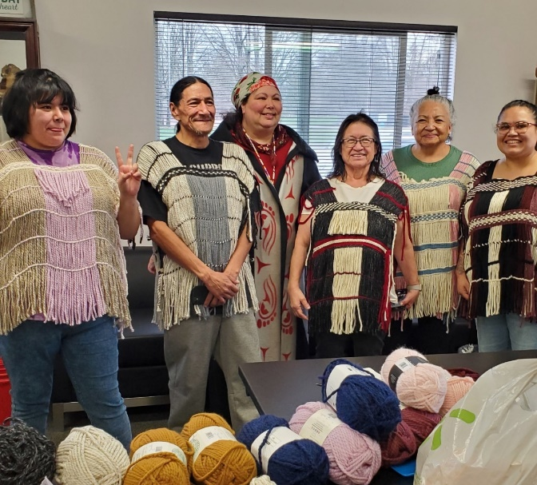

Financial Aid Department

The Financial Aid Division has the following programs to
service Tribal members; Transition Services (previously
known as Developmental Disabilities), Private School
Assistance, Scholarship, and Workshops & Training. We
are here to assist students with their educational costs and
provide support services to ensure student success while
attending colleges/universities to pursue their careers and
earn their diplomas, certificates and/or degrees.

Scholarship Highlights for 2024

Financial Aid/Scholarship Department accomplishments:
- Orientation to which 149 students attended
- Higher Education graduation ceremony
- Updated the Financial Aid portal application website
- Mailed out Care Packages in Spring and Fall
- Career Advisors provided ongoing support during MTS Senior Portfolio Days
- Career Day
- Highest Scholarship recipients ever: 254 in Fall 2024
- Quarterly mid-term tutoring sessions
- Career Advisors held 3 workshops at MTS on resume building
- Assisted with the Effective Teaching Institute
- Tabled at the Washington State Fair, AHS College Fair and Transition Fair at Muckleshoot Tribal School and Tomanamus Day
- 435 advising appointments
- Finalized the department 5-Year action plan
- Implemented texting base with students
- Implemented a quarterly scholarship newsletter sent to all students

The Scholarship Program recognized 32 Muckleshoot Tribal Members who earned a degree in the following categories:

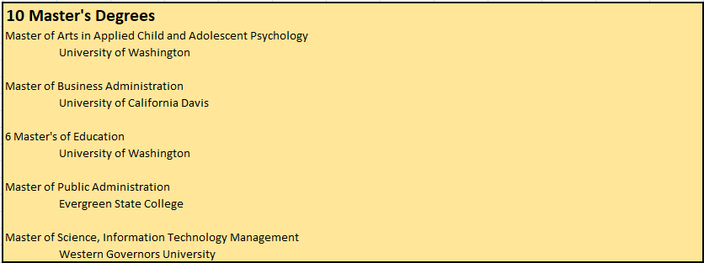

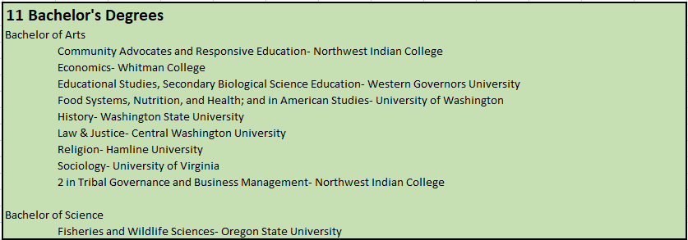
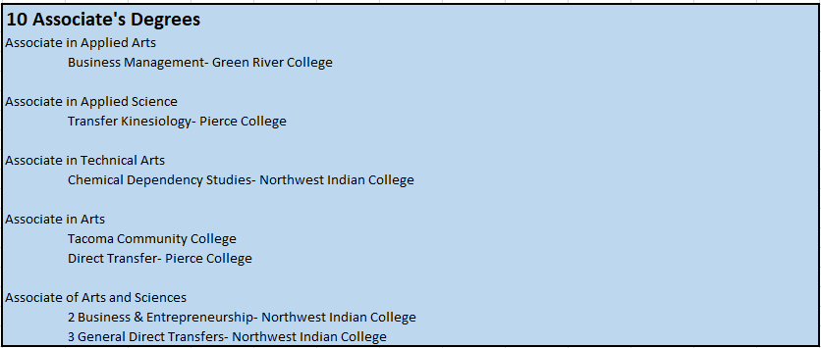

- 127 Certificates in all categories and schools.
- 18 High School 21+ Diplomas – Renton Technical College & Grays Harbor College

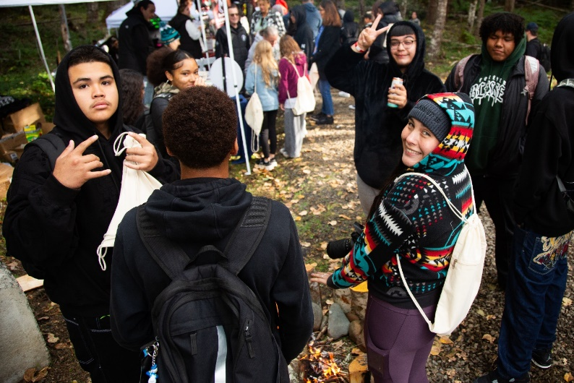

Transition Services:
The Transition Services Program provides financial assistance to Muckleshoot Families in need of tutoring services in all subjects to ensure a successful academic year. Funding is also available for pre-school and before/after school extended learning.

Highlights

- 29 Tribal Members funded to at attend various learning centers
- 21 Tribal Members funded for before and after school extended learning

Private School Assistance Program:
The Private School Assistance Program (PSAP), is a financial assistance program that pays for application fees, registration fees, transportation services, meals, testing fees, boarding and tuition fees for Tribal Members age groups from Preschool and Pre-Kindergarten up to 18 years of age.

Highlights

- 75 Tribal Members attend 24 different private schools
- Created and hired a new Finance Specialist

Outlook For 2025

Scholarship plans to hire another College and Career Advisor, contract a Policy Development consultant to work on merging Amendments into the Scholarship policies, and hire a Financial Aid Director Trainee.

Workshops & Training

PROGRAM MANAGER: Dena Starr
EXECUTIVE ASSISTANT: Lori Williams
LOCATION: 38977 172nd Ave SE Auburn, WA 98092
PHONE: (253) 876-3147
EMAIL: Dena.Starr@Muckleshoot.nsn.us

Workshops & Training

Workshop & Training funds enrolled Muckleshoot Tribal Members on a biennially basis (once every 2 years; up to $1,800 per client) to attend any educational and wellness workshops, conference, or training. The funding is to cover registration fees, travel expenses, lodging, per diem and shuttle fees. Applications must be submitted at least 30 days prior to the event for approval.

Highlights for 2024

- Vest Weaving class
- Gathered medicinal medicines
- Worked with Recovery program and sent clients to Recovery event
- Supported several individuals with career advancement

Outlook for 2025:
- Workshops & Training will work on providing small on-site workshops.
- Transition Services will work on revising the Program Policies.
- Continue to reach out to junior and senior private high school students and families for post-secondary planning.

Native American Career & Technical Education (CTE) & Cedar Tree Grant

EXECUTIVE DIRECTOR OF ADULT & HIGHER EDUCATION: Dr. Denise Bill, Ed.D
TRIBAL COLLEGE ADMINISTRATOR: Madrienne White
PROGRAM MANAGER: Larry Cordier
LOCATION: 39811 Auburn Enumclaw Rd. SE, Auburn, WA 98092
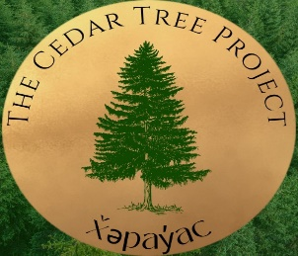
PHONE: (253)876-3256
EMAIL: Lawrence.Cordier@Muckleshoot.nsn.us

Career and Technical Education

The goal of the Cedar Tree Project is to provide students
with a seamless pathway to further their education and careers
with in-demand skills such as: computer technology, Natural
Resources, while infusing leadership skills in an Indigenous
friendly environment.

Native Leadership Program

This program was developed to build leadership skills for the
participants through an Indigenous lens. The Native Leadership Program infuses attendees with leadership skills and perspective from local Indigenous scholars, professionals and elders; to give
holistic experiences, Indigenous Knowledge and perspectives.

Natural Resources Program

The Muckleshoot Tribal College has partnered with Green River College to provide an Associate of Applied Science degree in Natural Resources. Students have the opportunity to learn about the northwest forest environment, watershed, wildlife management through the classroom and work based learning. Currently there are six students, three are Muckleshoot Tribal Members.

Filmmaking Foundations

Prepares students to develop the foundations of digital filmmaking and multimedia production.

Audio Production

Audio foundations prepares students to develop skills in sound and music production.

Microsoft Office, Basic – Intermediate – Advanced

This three-part series incorporates the Word, Excel, and PowerPoint applications with wide knowledge in hardware, software, cabling, social media, etc. on a path to earning an IC3 certification.
The Internet and Computing Core Certification (IC3) is a digital literacy exam that covers basic computing, internet knowledge, and skills formational credentials. Successful completion of the IC3 demonstrates that you have the knowledge and skills required for basic use of computer hardware, software, networks, and the internet. After completing and testing out of all three levels, the students will earn the IC3 certification, which is recognized worldwide.

Financial Literacy Workshop

Students gain financial skills in investing strategies and budgeting.

Early College Program

Students are offered educational opportunities designed to lead to a path to college.

Student Statistics

Class Name | Graduates/Attendees | Muckleshoot Graduates
Native Leadership Program | 161 | 81
Filmmaking I | 12 | 8
Audio Production | 9 | 9
MS Basic | 29 | 24
MS Intermediate | 14 | 14
MS Advanced | 10 | 10
MS Excel | 11 | 9
Early College Program | 7 | 7
Certified Nurses Program | 11 | 3
Carpentry Cohort | 11 | 9
Early Child Education | 1 | 1
Financial Literacy | 67 Attendees | 60

Early College Program (ECP)

EXECUTIVE DIRECTOR OF ADULT & HIGHER EDUCATION: Denise Bill, Ed.D
MUCKLESHOOT TRIBAL COLLEGE ADMINISTRATOR: Madrienne White
ACADEMIC AFFAIRS INSTRUCTOR: Patrick Eagle
CONTINUING EDUCATION COORDINATOR: Justine Koble
LOCATION: 39811 Auburn Enumclaw Rd. SE, Auburn, WA 98092
PHONE: (253) 294-8081, (253)876-3375
EMAILS: Patrick.Eagle@Muckleshoot.nsn.us , Justine.Koble@Muckleshoot.nsn.us

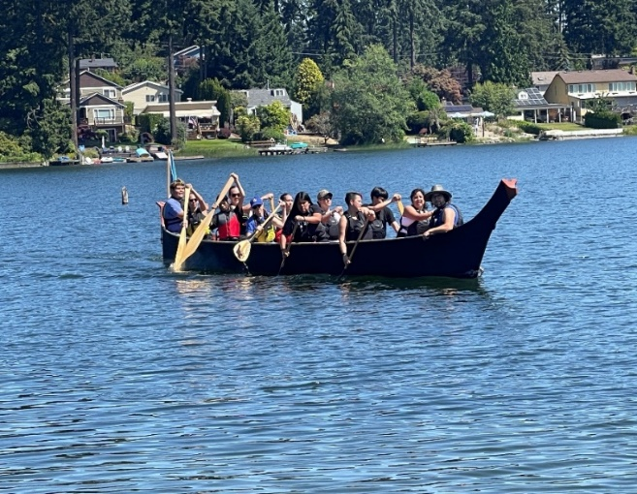

Early College Program 2024

The creation of the Early College Program (ECP) begins with
Dr. Denise Bill’s leadership in the summer of 2009.Since then,
ECP has offered educational opportunities (in and out of the
classroom) to 186 Native students.
There have been 133 Muckleshoot Tribal Members, 16 Native
students from various Tribes, and 37 community members.
Over the years, our ECP students have successfully completed
courses ranging from Math, English, Office Basics, P.E.,
Muckleshoot Village Site History, Cooking, Financial Literacy,
and campus visits to local Washington state colleges and universities.
- To ensure our students received dual credit (high school and college credit), we partnered with Northwest Indian College. Our partnership allowed us to offer six courses: (1) Village Sites taught by Wayne Buchanan and Justice Bill, (2) Microsoft Office taught by Joshua Hawks, (3) Basketball taught by Nathaniel Bisson, (4) Social Justice taught by Justine Koble, (5) Financial Literacy taught by Patrick Eagle, and (6) Wellness taught by Justine Koble and Dr. Denise Bill.
- This summer, twelve students (seven Muckleshoot Tribal members, one Native from another tribe, and four community members enrolled in ECP 2024.
- ECP students experienced an Indigenized curriculum, which gave students the opportunity to learn about culture, language, and identity – which informs our personal and professional lives.

Our students excelled academically. The chart bellows illuminates 49/53 passing grades for this year’s 2024 Early College Program.

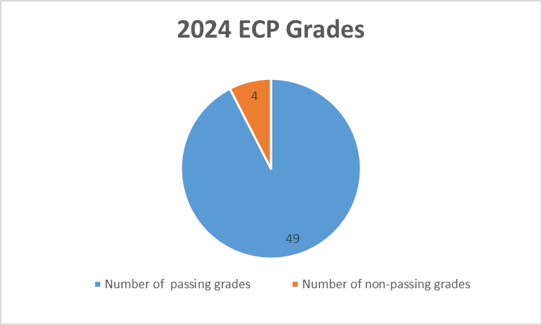

Continuing Education

EXECUTIVE DIRECTOR OF ADULT & HIGHER EDUCATION: Denise Bill, Ed.D
MUCKLESHOOT TRIBAL COLLEGE ADMINISTRATOR: Madrienne White
CONTINUING EDUCATION INSTRUCTIONAL COORDINATOR: Justine Koble
LOCATION: 39811 Auburn Enumclaw Rd. SE, Auburn, WA 98092
PHONE: (253) 876-3375
EMAIL: Justine.Koble@Muckleshoot.nsn.us

Continuing Education Department

The Continuing Education Department serves the Muckleshoot Community by offering a range of workshops and programs for personal enrichment and educational recovery. Programming offered results in the obtainment of a high school diploma, or high school equivalency for the learner. Workshops are taught by cultural experts in their field and are offered to enrolled students and community members.

General Education Development (Program (GED)

Continuing Education works to prepare adult learners in the Muckleshoot Community to obtain their high school equivalency, or GED. We seek to serve students by offering free or low cost educational support. Successful completion of the GED program empowers individuals to achieve their personal and professional goals, contributing to their community and the workforce.

Program Outcomes:
- GED Student enrollment: 1 student.
- Offering independent virtual GED test preparation.
- Our Muckleshoot Tribal College Testing Center has expanded to offer Northwest Indian College students the ability to take in-person placement testing, as well as other virtual/remote testing by appointment. Students are able to test in-person at one of our three testing stations.
High School 21+ Program (HS21+)

Adult students work with an RTC instructor and the instructor at the Muckleshoot Tribal College Education Resource Specialist to demonstrate competencies in reading, writing and math contextualized in science, history, government, occupational studies, and digital literacy. The program combines culturally relevant current coursework with previous learning, and work and life experiences to result in a Washington State High School Diploma. The HS21+ program empowers adult learners to take charge of their education, ensuring they are equipped with the relevant skills needed for success in their chosen fields.
- HS21+: 17 enrolled students, 14 MIT, 2 other tribally enrolled, 1 community member
- 37 graduates, 23 MIT, six more than previous year.
- One-on-one tutoring available via appointment and drop-in with instructor.
- Collaborates with multiple MIT departments to provide wrap-around support for tribal members in need of high school diploma.
- Provides personalized accommodations for students with diverse learning needs.
- Collaborates with Renton Technical College to provide culturally relevant options for high school credits.

Effective Teaching Institute (ETI)

EXECUTIVE DIRECTOR OF ADULT & HIGHER EDUCATION: Denise Bill, Ed.D
MUCKLESHOOT TRIBAL COLLEGE ADMINISTRATOR: Madrienne White
CONTINUING EDUCATION INSTRUCTIONAL COORDINATOR: Justine Koble
HIGHER EDUCATION RESEARCHER & ANALYST: Michelle Williams
LOCATION: 39811 Auburn Enumclaw Rd. SE, Auburn, WA 98092
PHONE: (253) 876-3375, (253) 876-3243
EMAIL: Justine.Koble@Mucklshoot.nsn.us, Michelle.Williams@Muckleshoot.nss.us

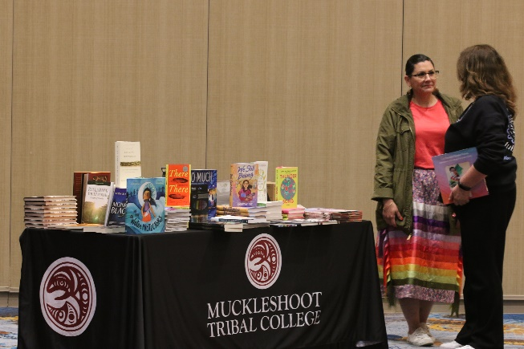

Effective Teaching Institute

The Effective Teaching Institute for Native
Learners originated with Dr. Willard Bill Sr. and
Mr. Jim Egawa in the 1980’s. The leadership of
this work was then passed on to Dr. Denise Bill
and Madrienne White. Although its format and
content have evolved over the years, the basic
concept of engaging in effective practices for
Native students is the core of this work.

- 163 educators registered to attend June 25-27, 2024.
- Event was hosted in the Muckleshoot Casino Events
Center.
- Hosted in collaboration with Muckleshoot Tribal School, who provided educator clock hours.
- Collaboration with Washington State Office of Native Education to host Strengthening Tribal Consultation training for School Board Members and District Superintendents. 50 attended training.
- Breakout sessions included options for early childhood education-high school and higher education.
- Daily workshops included “Muckleshoot Mornings” where educators could learn more about Muckleshoot history, culture, and language.
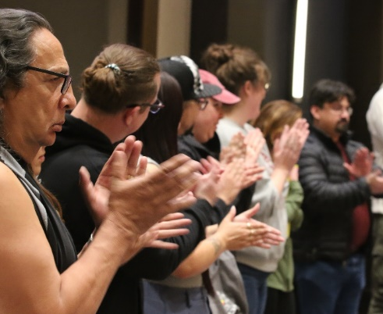
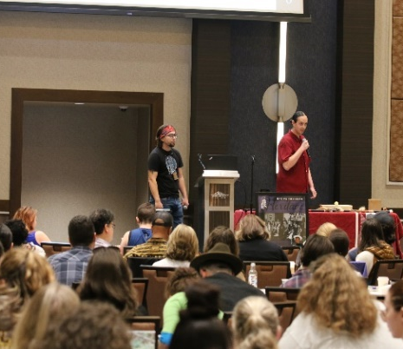
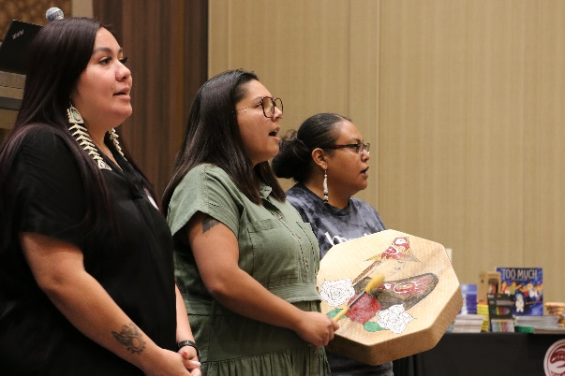

Sunshine Committee

EXECUTIVE DIRECTOR OF ADULT & HIGHER EDUCATION: Denise Bill, Ed.D
COMMITTEE MEMBERS: Dr. Denise Bill, Madrienne White, Amy Castaneda, Justine Koble, Kelsey Perkovich, Loretta Sohappy, Joshua Hawks, Justice Bill, Michelle Williams, Patrick Eagle
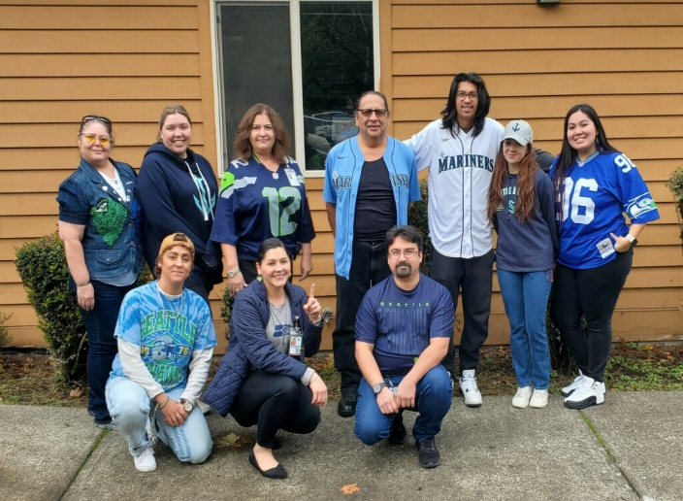
Sunshine Committee
The AHE Sunshine Committee started in January 2023, and
is a fun group of employees dedicated to brightening up the
office atmosphere. They plan social events, celebrate special
occasions like birthdays and work anniversaries, and create
opportunities for team bonding. Think of them as the cheer-
leaders of the workplace, focused on fostering a friendly and
supportive environment. Their efforts help everyone feel
more connected and engaged, making the workplace a
happier place to be! Over a lifetime, on average, you will
spend 90,000 hours (1/3 of your life) at work. During those
hours, why not have some office fun!? Thank you Sunshine Committee for all you do.

- Monthly staff birthday celebrations at All Staff Meetings
- Holiday celebrations such as Valentine’s Day Staff Treats, Easter Egg Hunt, Halloween Door Decorating Contest, Holiday White Elephant and Gingerbread House Decorating.
- Chartered a Coffee Cart for staff and students to enjoy.
- Celebrated our instructors for Instructor Appreciation Week.
- Got to know our staff better by selecting their favorite treats and books.
- Organized potlucks encouraging team bonding, fostering collaboration, and allowing everyone to share their culinary traditions in a fun and relaxed environment.
- Hosted Cultural workshops like Mindfulness Seminar, Paddle-making and beading classes.
- Student engagement opportunities by hosting three Spirit Weeks.
- Provided staff with a back-to-school beverage from Paddles Up as a pick-me-up.
- Hosted a team lunch at Market253 to thank staff for a great summer session.
- Celebrated the end of the summer with a Back-to-School Fiesta.
- Hosted a games day to strengthen team building, promote collaboration, boost communication, and foster a spirit of friendly competition among colleagues.
- Offered a staff viewing of the NMAI Native Cinema Showcase support workplace indigenization by providing a platform for Indigenous voices and stories, fostering cultural understanding, and enriching our team’s appreciation of diverse perspectives
- Hosted two trivia contests to provide a fun break from routine, foster a sense of camaraderie, and spark friendly competition that helps build stronger relationships among staff
- Organized a fun book club, providing staff an opportunity to read and discuss together literature by Indigenous authors

