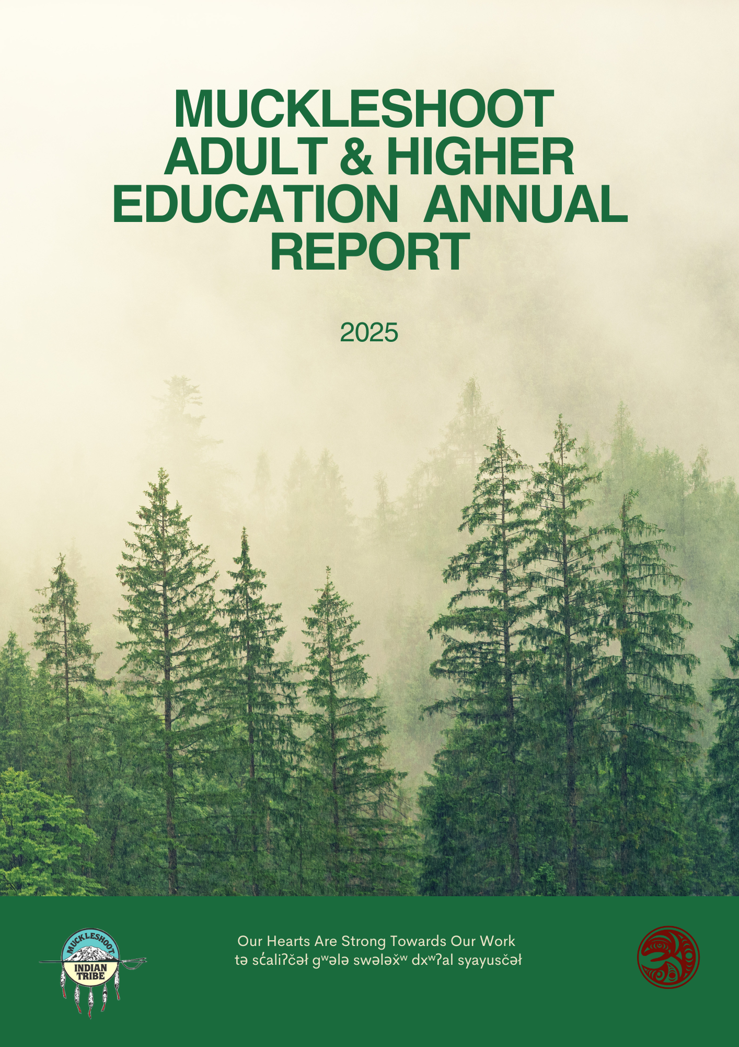

Adult & Higher Education Division

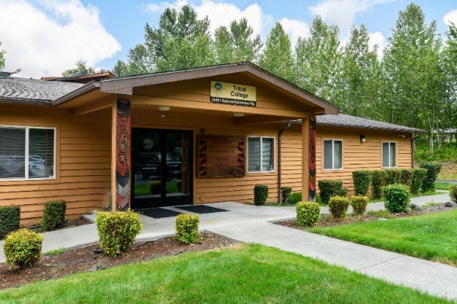
Executive Director of Adult and Higher Education: Denise Bill, Ed.D
Location: 39811 Auburn Enumclaw Rd. SE, Auburn, WA 98092
Phone: (253)876-3345
Email: Denise.Bill@Muckleshoot.nsn.us

The Adult and Higher Education Division of the
Muckleshoot Department of Education consists
of the following departments:
- Muckleshoot Tribal College
  - GED/HS21+
  - Native American Career and Technical
Education Programs
  - College & University Partnerships
- Financial Aid
  - Scholarship
  - Workshops & Training
  - Internship Program
  - Transition Services
  - Private School Assistance Program
- College and Career Education Opportunities
(CCEOP)

Financial Aid Department

Location: Scholarship Building and MIT College- Scholarship
38977 172nd Ave SE 39811 Auburn Enumclaw Rd. SE
Auburn, WA 98092 Auburn, WA 98092

Staff:
Denise Bill Exec. Dir. of Adult & Higher Education (253) 876-3345
Marie Marquez Financial Aid Director (253) 876-3382
Sahara Singh Financial Aid Director Trainee (253) 876-3013
Amy Castaneda Financial Aid Manager (253) 294-8032
Jocelyn Patterson College and Career Advisor (253) 876-3305
Kelsey Elmore College and Career Advisor (253) 876-3210
Fabian Mendoza College and Career Advisor (253) 294-8257
Lydia Adira College and Career Advisor (253) 294-8258
Danielle Wilcox Finance Specialist (253) 294-8002
Anita Jimenez Finance Specialist (253) 876-3378
Loretta Sohappy Finance Specialist (253) 876-2830
Cheri Wilbur Finance Specialist (253) 294-8247
Dena Starr Workshops & Training Manager (253) 876-3147
Laurie Starr-Williams W & T Administrative Specialist III (253) 876-3381
Vacant Internship Coordinator (253) 294-8125

Department Summary: The Financial Aid Division has the following programs to serve Tribal members; Transition Services (previously known as Developmental Disabilities), Private School Assistance, Scholarship, Workshops & Training and the new Internship Program. We are here to assist students with their educational costs and provide support services to ensure student success while attending colleges/universities to pursue their careers and earn their diplomas, certificates and/or degrees. The Muckleshoot Indian Tribe

Scholarship Highlights for 2025:
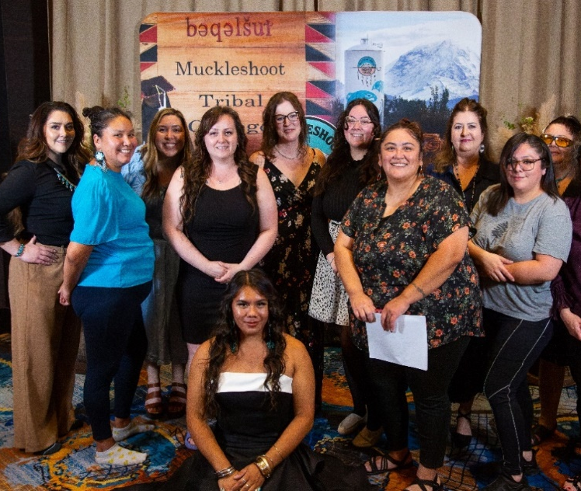
Financial Aid/Scholarship Department accomplishments:
- Orientation to which 260 students attended (Winter ’25 to Fall ’25)
- Higher Education graduation ceremony
- Hired 3 new staff members: the Financial Aid Director Trainee and 2 College and Career Advisors
- Launched the Scholarship series, a monthly workshop for Scholarship students to build community, learn school and life skills, and develop engagement
- Career Advisors provided ongoing support during MTS Senior Portfolio Days and Career Day
- Launched the Internship Program
- Digitized all Scholarship applications and the appeal form
- Highest Scholarship recipients ever: 272 in Fall 2025
- Quarterly mid-term tutoring sessions (11 held)
- Assisted with the Effective Teaching Institute
- Tabled at the Casino Benefits Fair, MELA Resource Fair and Transition Fair at MTS and Tomanamus Day
- Visited students on campus and the University of Washington-Tacoma, Green River College, and Western Washington University

The Scholarship Program recognized 41 Muckleshoot Tribal Members who earned a degree in the following categories:
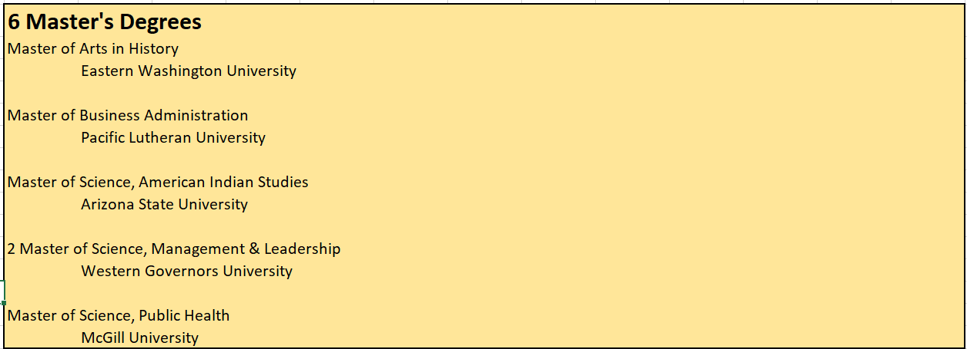

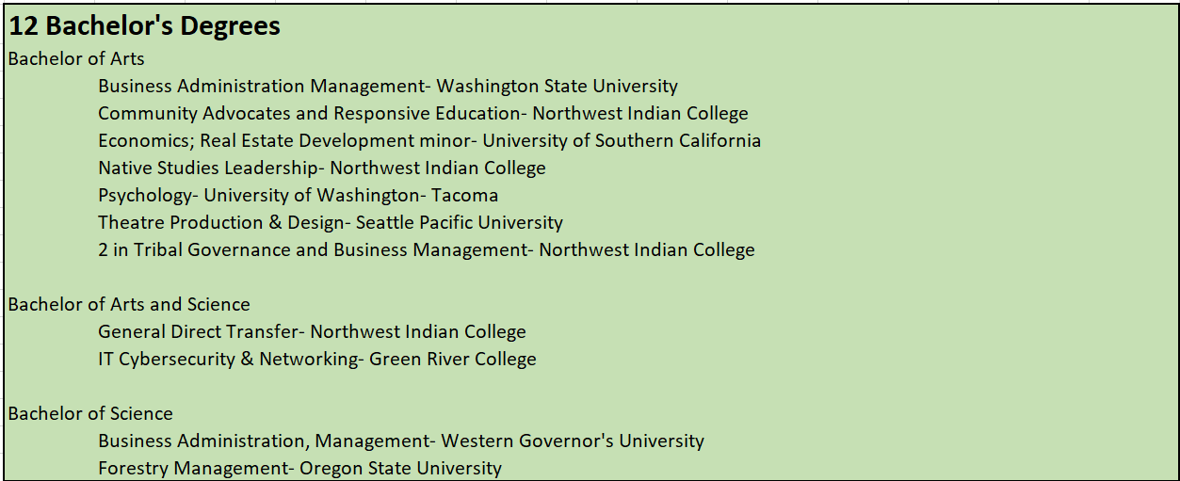

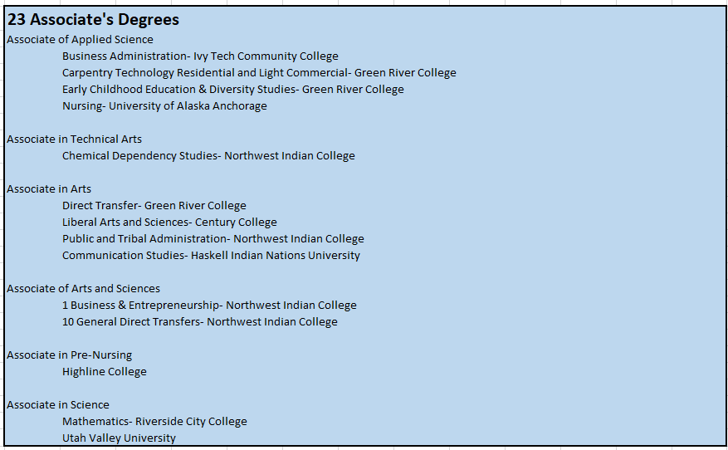
- 134 Certificates in all categories and schools
- 16 High School 21+ Diplomas/GED

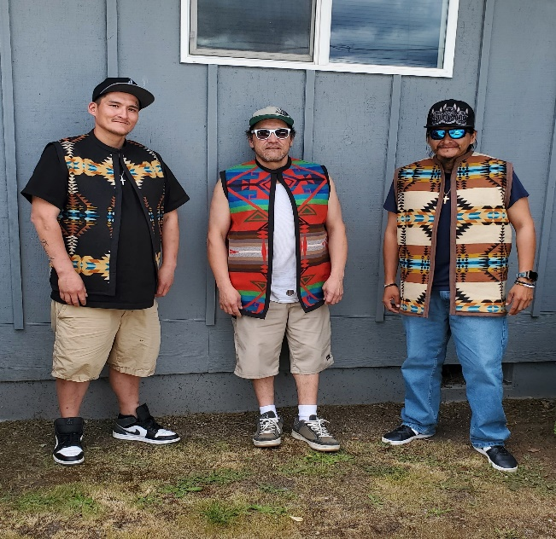
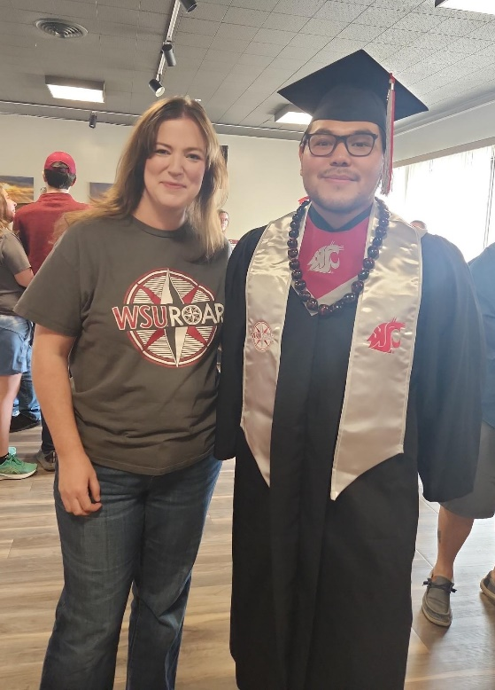
Outlooks for 2026:
Scholarship plans to create more school partnerships, in order to facilitate easier completion of the Financial Needs Analysis, FNA. Also, have an ongoing relationship with colleges/universities to be able to collect invoices on a timely manner, in order to process payments to schools with the appropriate credits/charges. Do more onsite visitations to students at their campuses, in order to make sure students are aware of school services. Contract a Policy Development consultant to revamp the Scholarship policies.

Workshops & Training
Workshops & Training Manager: Dena Starr
Location: 38977 172nd Ave SE, Auburn, WA 98092
Phone: (253) 876-3147
Email: Dena.Starr@Muckleshoot.nsn.us
Overview
Workshop & Training funds enrolled Muckleshoot Tribal Members on a biennially basis (once every 2 years; up to $1,800 per client) to attend any educational and wellness workshops, conference, or training. The funding is to cover registration fees, travel expenses, lodging, per diem and shuttle fees. Applications must be submitted at least 30 days prior to the event for approval.
2025 Highlights:
- Vest sewing Class
- Gathered medicinal medicines
- Worked with Recovery program and sent clients to Recovery event
- Supported several individuals with career advancement
- Designed native inspired items for Education events.
- Research on family history.
- Honoring brothers and tribal history event.
- Supported several tribal cleaning services with their training.
Outlook for 2026:
The Workshop & Training Program will work on ways to provide more on-site Workshops.

Transition Services
The Transition Services Program provides financial assistance to Muckleshoot Families in need of tutoring services in all subjects to ensure a successful academic year. Funding is also available for pre-school and before/after school extended learning.
2025 Highlights:
- 28 Tribal Members funded to at attend various learning centers
- 15 Tribal Members funded for before and after school extended learning

Outlook for 2026:
Transition Services will work on revising the Program Policies.

Private School Assistance Program
The Private School Assistance Program (PSAP), is a financial assistance program that pays for application fees, registration fees, transportation services, meals, testing fees, boarding and tuition fees for Tribal Members age groups from Preschool and Pre-Kindergarten up to 18 years of age.
2025 Highlights:
- 80 Tribal Members attend 23 different private schools
- 5 senior students graduate high school

Outlook for 2026:
Continue to reach out to junior and senior private high school students and families for post-secondary planning.
Internships:
The Internship Program provides valuable work experiences, skill developments, and career preparations for the workforce, with emphasis on professional growth and readiness for full-time employment. This program has two types of internships: the Emerging Professional (Muckleshoot Tribal Members who have earned a degree (B.S., B.A., M.A., Ed.D./Ph.D.) are eligible for internships year-round) and the Student Internship (The MIT Internship Coordinator develops and secures internships for current MTM degree seeking Scholarship students, based on professional and academic goals.).
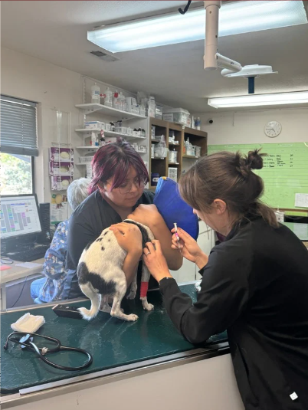
2025 Highlights:
Launched the new program in May
- Hired 10 interns for Summer:
  - 3 Emerging Professionals
  - 7 Student Internship
- Hired 6 interns for Fall:
  - 1 Emerging professional
  - 5 Student Internship
- Hosted 4 Internship info sessions
- Brought 3 Internship participants to the Native Women's Leadership Forum
- The sites we have placed students include:
  - MIT Legal Office
  - Thurston Regional Planning Council
  - Department of Development Services
  - Lakefield Veterinary Group
  - All Creatures Animal Hospital
  - Tacoma Musical Playhouse
  - WSU Football Program
  - Cambria Greenspace
Outlook for 2026:
To hire a Finance Specialist to help assist the program

Other Programs:

Student Services:
- Student Support Services (tutoring, math and writing center, tech support)
- Educational Advising / Degree Planning
- Registration Assistance
- Education and Career Goal Setting

Student Enrollment Numbers (Muckleshoot Site Students):
Term | Student Enrollment #s
Fall 2024 | 88
Winter 2025 | 86
Spring 2025 | 93
Summer 2025 | 75
Fall 2025 | 93

Degrees Conferred 2024-2025 – Total: 24
- AA -General Direct Transfer – 9
- BA - Tribal Governance and Business Management – 3
- BA - Community Advocates and Responsive Education – 3
- AAS - Business and Entrepreneurship – 3
- AAS - Public & Tribal Administration – 2
- APS - Early Childhood Education-Transfer – 1
- AST - Chemical Dependency Studies – 1
- Initial Early Childhood Education Certificate – 1
- Entrepreneurship Certificate – 1

College Career Educational Opportunities Program (CCEOP)
Program Manager, Michele Rodarte
Acting Manager CCEOP, Michelle Williams
Lead Supervisor, Josie Benito

Program Overview:
The mission of the Muckleshoot College and Career Education Opportunities Program (CCEOP) is to introduce Muckleshoot Tribal members, descendants, and community members ages 14 to 18 who live in Muckleshoot households to hands-on work experience and academic learning opportunities. The program helps participants make informed decisions and take meaningful steps toward their future careers. While careers within Muckleshoot Tribal enterprises remain a primary focus, participants aged 16 and older may also explore work opportunities outside the Tribe.
It is an initiative of the Muckleshoot Tribe to hire as many youth as possible throughout the year to provide valuable, hands-on learning experiences. The College and Career Education Opportunities Program (CCEOP) operates two sessions annually—one during the school year and one during the summer. In 2025, CCEOP served more than 100 youth during the summer session and welcomed its largest school-year cohort yet, with 75 participants.

CCEOP School Session October 14, 2025 to May 29, 2025: (75 Youth)
With the help of Acting Manager, Michelle Williams and with the expertise of Josie Benito, this school session launched with great success. Together with HR’s Kelly Griffin and Chandra Moses, they redesigned the student orientation to include interactive activities such as BINGO, dynamic student engagement, and a fully updated PowerPoint presentation.
In the coming months, CCEOP will continue revamping its systems, forms, and procedures to better manage the growing number of youth participants in future years. The team is developing new onboarding documents to enhance communication with students, parents, and staff; ensuring every participant receives the best possible experience in this valuable program.
Workshops Completed So Far:
- October 21, 2025, CCEOP Youth Workers Workshop at MTC for the IAIA Institute of American Indian Arts. Free & open to all, students, Tribal, and Community members. Food and Drinks provided!

CCEOP Summer Session Start July 7, 2025 to August 15, 2025: (100 + Youth)
Workshops Completed:
- July 7, 2025 CCEOP Summer Session Orientation @ the Pentecostal Church
- July 10, 2025 Puget Sound Skills Center: Visit, and exposed youths the varieties of Career Fields of opportunities:
- Advanced Construction Technology
- Aeronautical Science Pathways
- Aerospace Manufacturing & Engineering
- Auto Body Technology
- Automotive Technology
- AWS Cloud Academy
- Biomedical Research & Global Health
- Cyber Security
- Dental Assisting
- Design & Marketing
- DigiPen Video Game Programming (AP)
- Digital Sound Recording
- Fire & Emergency Services
- Law & Justice
- Marine Science Technology
- Multimedia Design
- Pre-Nursing
- Pre-Veterinary Technology
- Digital Art and Video
- Teaching Academy
- The Institute for Culinary Arts & Sciences

- July 21, 2025 Canning Salmon with Laura Starr at the Pentecostal Church
Molds Paintings
Beadings
Colored by Numbers

- July 23 to August 5, 2025, Canoe Journey in Lower Elwha, Washington.
This cultural event has been around immemorial times. An Event full of reflection and renewal for tradition, preserving the customs and wisdom passed down through countless generations. This is a turning season of significant moment in our shared history.

- July 24, 2025, Taqualshed Belts by Ms. Teresa Jerry. Learning how to make belts for berry picking baskets that will last awhile.

- Language by Donna Starr. Learning phrases and introduction to Muckleshoot Basic Language.

Stick Games by Albert Moses. Learning the Basic Rules of the games, how it works and how it plays at cultural events.

- July 31, 2025, West Coast Training: Visit Heavy Equipment Machinery. A field of Machinery Engineering, Truck Driving, and Heavy Equipment Operators. This is one of the best one on one training and many hands on and on the Job Training. We had two youth workers that was very much interested of signing up.

- August 1, 2025, Muckleshoot Casino Job Fair: This is to learn the trades, skills, and be familiarize with what the Muckleshoot Casino Resort have to offer. The Muckleshoot Casino Resort also have the CAT Program for Enrolled Tribal Members.

- August 7, 2025, Renton Technical College: Visit to learn what Technical College is all about and what they have to offer! Renton Technical College has the best Culinary Art Classes and to get a degree to become one of the best Chef in Washington State. Renton Technical College has the best Automotive and Auto Body Classes in high tech. I believe that exposing youths at earlier year on in their career will get them interested in Colleges.

- The month of September, CCEOP staff working on screening and mock interviews for all selected youth workers for the 2025-26 School Session along with HR on boarding new hires paperwork and drug screening.
- January 21, 2025, Auburn Aviation Workshop: A legacy of Innovation and excellence. Shaping the next century of flight. The Auburn Aviation School operates to develop professional pilots and thought leaders who will serve as a positive force in aviation and the world.

Muckleshoot Tribal College
ACADEMIC AND OPERATIONS MANAGER: Madrienne White, EMPA
LOCATION: 39811 Auburn Enumclaw Rd. SE, Auburn, WA 98092
PHONE: (253)876-8082
EMAIL: Madrienne.White@Muckleshoot.nsn.us
Mission Statement
“The Muckleshoot Tribal College is a Tribally directed education leader, promoting lifelong learning and the power to choose. Through strategic partnerships, we create a culturally inspiring environment that expands academic and career opportunities for our immediate Tribal family and extended Community.”
2025 Highlights
Community Engagement
Muckleshoot Tribal College (MTC) continues to offer place-based education that benefits and engages our Tribal members and the larger community. This year, we sent out a Tribal-wide survey asking what classes or programs the community would like to see us offer. We received more than 80 responses and were able to craft our grant initiatives from this list. Here at MTC, we strive to meet the needs of our students and community through ongoing collaboration and responsiveness.
MTC staff continually engage with our Muckleshoot membership and community by attending and hosting public gatherings, Tribal events, school recruitment activities, and cultural celebrations. For example, we’ve tabled at Tomanamus Day, the Veteran’s Resource Fair, our annual Career Day, the Effective Teaching Institute, and the Washington State Fair. We also enjoy taking part in national presentations, local guest lectures, and publishing opportunities that highlight our work and mission.
Within our building, we value close collaboration with the Continuing Education Program, Career and Technical Education Program, the Early College Program, and the Adult and Higher Education team. Beyond campus, we maintain strong partnerships with institutions such as Pierce College, Renton Technical College, Shoreline College, Green River College, Seattle Colleges, the University of Washington Tacoma, and Northwest Indian College. Denise Bill and Madrienne White continue to oversee several MOUs with these partners, while Denise also serves on the Washington State Board of Community and Technical Colleges, attending quarterly statewide meetings.
Through hosting events like the Effective Teaching Institute, which welcomed more than 300 attendees this year, along with campus tours, workshops, and community-based meetings, MTC continues to cultivate meaningful relationships with our partners, students, and local families. These efforts ensure that our programs, services, and spaces remain welcoming, culturally grounded, and identity-affirming for all who engage with Muckleshoot Tribal College.
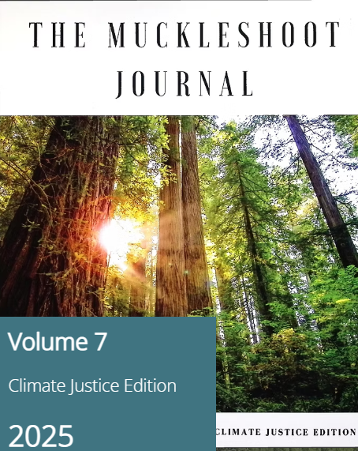
Publication: Muckleshoot Journal, 7th Edition
The seventh edition of the Muckleshoot Journal:
Climate Justice Edition highlights the voices and art of
Indigenous educators and students. This publication continues Muckleshoot Tribal College’s mission to honor Indigenous knowledge systems, celebrate Muckleshoot voices, and promote academic excellence rooted in community values. Featuring research articles, creative works, and beautiful art, the 7th Edition reflects MTC’s ongoing commitment to advancing Indigenous education and fostering educational dialogue. The Muckleshoot Tribal College is actively accepting submissions for their 8th edition until February 2026. They will publish the 8th edition roughly in the summer of 2026.

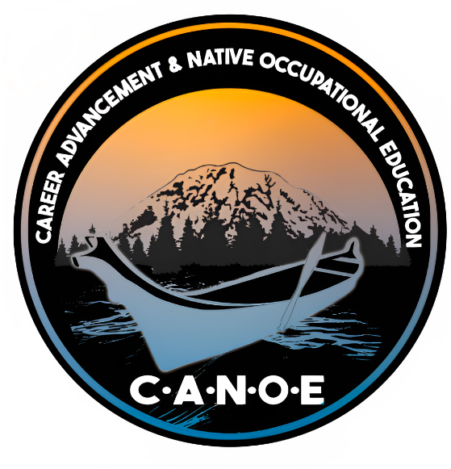
NACTEP Grant (The Canoe Project) Proposal
Figure 1 Logo created by Sam Obrovac
For more than twenty years, Muckleshoot Tribal College has successfully received funding through the Native American Career and Technical Education Program (NACTEP) grant each year. In this most recent grant cycle, Dr. Denise Bill, Michelle Williams, and Justine Koble, collaborated to create The CANOE Project; a compelling grant that was designed to strengthen Tribal workforce pathways, expand culturally grounded technical education, and align training opportunities with high-demand career sectors.
The project was built around strategic partnerships with institutions including Green River College, Evergreen State College, Renton Technical College, University of Washington Tacoma, and the Muckleshoot Casino Resort, along with Tribal, state, and regional industry partners. Through this grant, MTC will build stackable pathways that connect secondary, postsecondary, and career-based training.
Proposed program areas included Culinary Arts, Cybersecurity, Early Childhood Education, Entrepreneurship, and Healthcare, each integrating Native knowledge systems and sovereignty-based leadership principles. The CANOE Project sought to create flexible, accessible programs that support students from entry-level training to job placement.
The grant team and other staff at Muckleshoot Tribal College and the MIT Grants Department invested months of effort into every component of the proposal to ensure the project reflected sustainable, community-driven programming. Although the Grant competition was terminated due to the current presidential administration, the Canoe Project demonstrated MTC’s institutional capacity to build competitive federal proposals and its unwavering commitment to workforce equity and educational sovereignty. The work completed under this project will serve as a foundation for future grant submissions, Tribal workforce initiatives, and educational partnerships.
Once the government reopens, and if the NACTEP grant competition is re-released, Muckleshoot Tribal College intends to resubmit the CANOE Project proposal once again, reaffirming its commitment to advancing transformative, culturally grounded education and workforce development for the Muckleshoot Tribal members and the larger community.
Partnerships
As mentioned in our Mission Statement, partnerships are integral to the Muckleshoot Tribal College. Although MTC offers its own certifications, such as Microsoft Office, and various industry-standard certificates, as a non-accredited institution we rely on our partner colleges to help deliver place-based educational opportunities—offering college degrees and High School Diplomas directly on the Muckleshoot Indian Reservation.
However, while initiating partnerships, it is important for us to convey the importance and significance of respecting our students’ identity and connecting the academic content to our students in meaningful ways. While we value these partnerships that expand educational access and variety for our students, we also recognize our responsibility to uphold Muckleshoot Tribal and Educational Sovereignty. In all collaborations and negotiations, we make it a priority to educate our partners on the importance of respecting cultural and ancestral knowledges, understanding our students’ identities, and connecting academic content in meaningful, culturally grounded ways. As a Tribal institution, we hold ourselves accountable to our ancestors, our living and more-than-human relatives, and our community to ensure that our programs and partnerships reflect the highest respect for our homelands and values.
We at MTC acknowledge and celebrate our students’ cultural and tribal identity, we endeavor to ensure that any offerings at the Tribal College are delivered through an Indigenous lens and that materials and content are culturally relevant and responsive.
Coming this fall, 2025 – we will be partnering with Shoreline Community College for the long awaited entrepreneurship program. Originally a part of our new NACTEP Grant submission, this is such a desirable program that MTC is finding a way to offer it to our Tribal and community members long before we resubmit our NACTEP grant once again when funding becomes available.
Our partnerships within day-to-day activities and our NACTEP Grant Canoe Project proposal include but are not limited to: Northwest Indian College, Green River College’s Early Childhood Education and IT programs, Shoreline Community College, Renton Technical College, and many others. These relationships are central to advancing our shared mission of providing culturally relevant, place-based education that empowers our students, families, and Tribal Nation.
Muckleshoot Tribal College Digital Library Expansion
Over the past year, Muckleshoot Tribal College has made significant progress in advancing the vision of the Muckleshoot Digital Library, transforming it from a pilot project into a growing, accessible hub for cultural preservation and academic research. What began as an idea inspired by Dr. Willard Bill Sr. has evolved into a dynamic resource that connects students, faculty, and the Muckleshoot community to invaluable cultural, historical, and educational materials.
The college has successfully transitioned from the initial Kotobee platform to developing the long-term structure for the library’s next phase: integration with Washington State University’s Mukurtu platform. This Native-centered system honors Tribal sovereignty and data governance, ensuring that Muckleshoot culture, language, and creative works are shared responsibly and respectfully.
The Muckleshoot Digital Library continues to stand as a living archive of Muckleshoot knowledge, representing a bridge between generations of storytellers, scholars, and community leaders. As the college prepares to officially launch the Mukurtu-based platform in the coming year, it reaffirms its commitment to preserving Tribal knowledge through sovereignty-driven technology and continues to guide the educational and cultural journey of future generations.

Campus Safety and Emergency Preparedness
Throughout 2025, the Muckleshoot Tribal College has focused on our safety systems and emergency readiness through several key improvements, including new speed bumps, exterior lighting, and fire alarm testing in partnership with Public Works and Building Maintenance. In addition, staff participated in CPR/First-Aid and Bullying Prevention training in collaboration with Human Resources, and building enhancements such as pest control, privacy gap fillers, and mold testing were completed. Together, these updates ensure a safer, more resilient learning environment as the College continues to grow.
Need For a New Building
In 2025, Muckleshoot Tribal College experienced record engagement, with a dramatic increase in student and community sign-ins through our digital sign-in system. From January 1st, 2025, to November 2025, we recorded a total of 4,784 sign-ins; 878 were guests, and 3909 were students, a clear indicator of growth. Each year, the demand for space, classrooms, and student resources continues to rise, underscoring the urgent need for a new building that can support expanding programs, partnerships, and the continued advancement of Muckleshoot education.
Outlook for the Coming Year
In the coming year, our team will continue to advocate for and support the development of a new Adult and Higher Education building. Following a period of reduced engagement during the pandemic, we have seen a strong resurgence of Tribal and community members eager to begin or return to their educational journeys.
In the future, we envision offering a broader range of certificate and degree programs and hopefully one day, accreditation. Additionally, we aspire to design a space that supports working parents through supervised, child-friendly areas and fosters intergenerational learning by honoring elders and offering cultural programming such as storytelling and land-based education.
Beyond infrastructure, we remain committed to strengthening relationships with our academic, Tribal, and community partners. We aim to deepen existing collaborations, build new networks, and expand opportunities that advance culturally grounded, student-centered education. Guided by our values and teachings, we will continue striving to provide quality educational experiences that honor Muckleshoot culture and knowledge systems.

tə sc̓aliʔčəł gʷələ swələx̌ʷ dxʷʔal syayusčəł
(Our hearts are strong towards our work)

Native American Career & Technical Education (CTE) & Cedar Tree Grant
Program Manager, Larry Cordier
Location: 39811 Auburn Enumclaw Rd. SE, Auburn, WA 98092
PHONE: (253) 876-3256
INFO EMAIL: Lawrence.cordier@muckleshoot.nsn.us
Services Provided
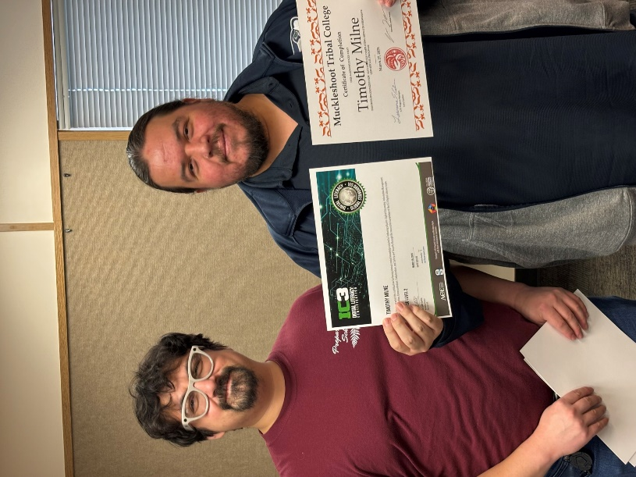
Career and Technical Education
The goal of the Cedar Tree Project is to provide students with a seamless pathway to further their education and careers with in-demand skills such as: computer technology, Natural Resources, while infusing leadership skills in an Indigenous friendly environment.
Native Leadership Program
This program was developed to build leadership skills for the participants through an Indigenous lens. The Native Leadership Program infuses attendees with leadership skills and perspective from local indigenous scholars, professionals and elders; to give holistic experiences, Indigenous knowledge and perspectives.
Natural Resources Program
The Muckleshoot Tribal College has partnered with Green River College to provide an Associate of Applied Science degree in Natural Resources. Students have the opportunity to learn about the northwest forest environment, watershed, wildlife management through the classroom and work based learning. Currently there are six students, three are Muckleshoot Tribal Members.
Financial Literacy Workshop
Students gain financial skills with investing strategies and budgeting.
Early College Program
Students are offered educational opportunities designed to lead to a path to college.
Microsoft Office: Basic – Intermediate – Advanced
This three-part series incorporates the Word, Excel and PowerPoint applications with wide knowledge in hardware, software, cabling, social media, etc. on a path to earning an IC3 certification.

The Internet and Computing Core Certification (IC3) is a digital literacy exam that covers basic computing, internet knowledge, and skills formational credentials. Successful completion of the IC3 demonstrates that you have the knowledge and skills required for basic use of computer hardware, software, networks, and the internet. After completing and testing out of all three levels, the student will have earned their ICE Certification, which is an industry certification recognized around the world.

Highlights of 2025
Student Statistics
Class Name | Graduates/Attendees | Muckleshoot Graduates
Native Leadership Program | 124 | 67
Filmmaking I  Filmmaking II | 2  2 | 2  1
Audio Production | 1 | 1
MS Basic | 51 | 40
MS Intermediate | 22 | 15
MS Advanced | 14 | 11
MS Excel | 11 | 11
Early College Program | 11 | 9
Certified Nurses Program | 12 | 3
Carpentry Cohort | 9 | 6
Early Child Education | 11 | 5
Financial Literacy | 66 | 62

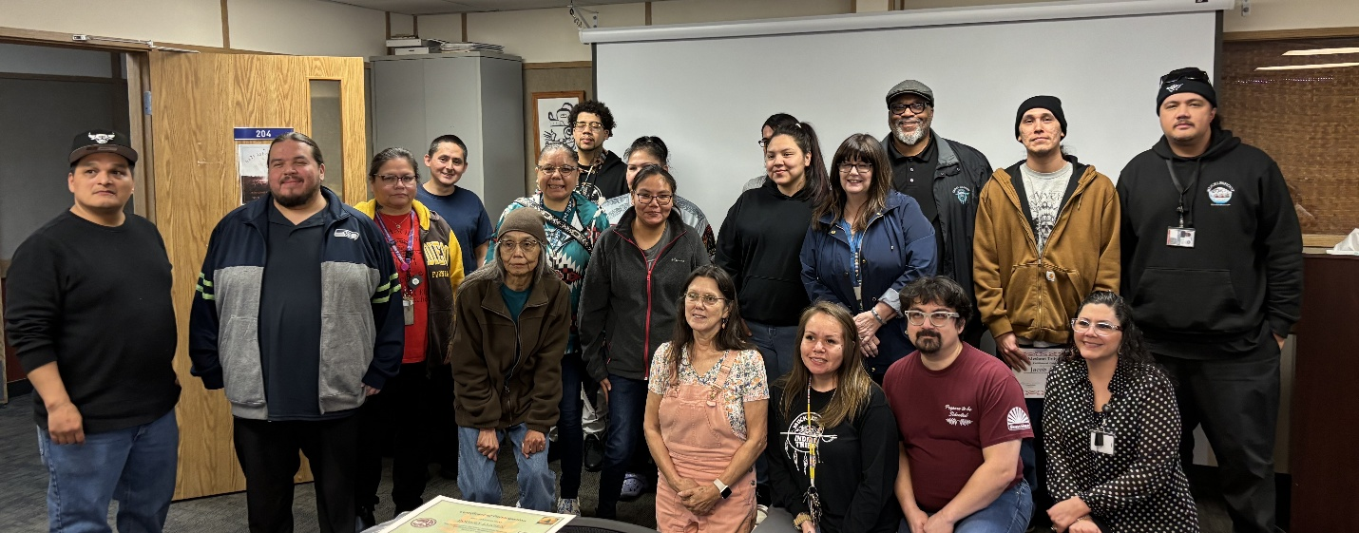

NLP-Native Leadership Program: January 31, 2025, Health & Wellness.
- Physical: Balanced nutrition, sufficient sleep, and managing illnesses effectively.
- Mental and Emotional: Focuses on psychological resilience, stress management, self-awareness, and emotional regulation. (Self-Care)
- Social: Relates to having a sense of belonging, building healthy relationships, and strong communication skills.
- Spiritual: Encourages reflection on one's values and life purpose. This includes religious faith, but it can also involve seeking meaning in everyday life.
- Intellectual: Involves learning and applying knowledge while challenging yourself with new experiences.
- Occupational: Focuses on finding purpose and satisfaction in your career or role.
- Environmental: Looks at how your surroundings—such as air quality, safety, and access to nature—affect your overall health.
Health and wellness are not just coping with yourself dealing sickness and others. Encompass a complete state of physical, mental, and social well-being. Wellness is an active, intentional, and ongoing pursuit of choices and activities that lead to a more balanced and fulfilling life.

MTC Instructional Coordinator Programs
Instructional Coordinator: Justice Bill
Location: 39811 Auburn Enumclaw Rd. SE, Auburn, WA 98092
Phone: (253) 876-8175
Email: Justice.Bill@Muckleshoot.nsn.us
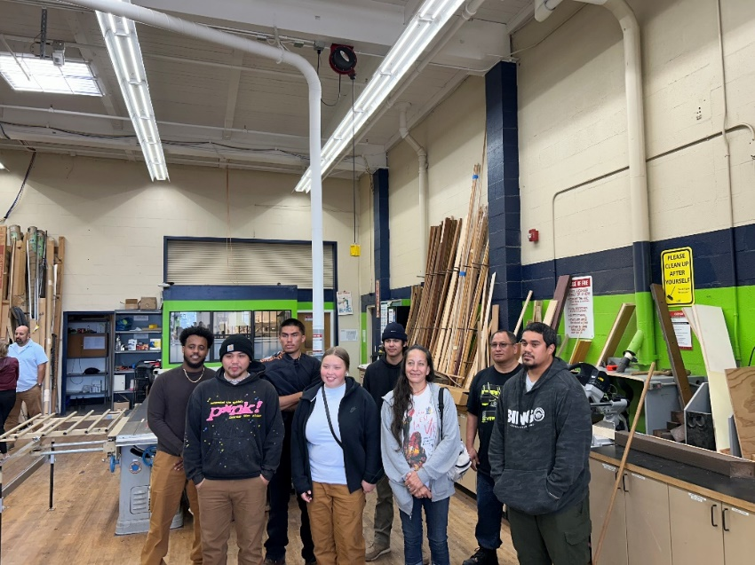
Pre-Apprenticeship Carpentry Program:
- Key partners:
  - Green River College
  - Muckleshoot Adult Work Training Program
  - Muckleshoot BOW (Building our Workforce) Program
  - Muckleshoot Housing Authority
- Program Offerings:
  - Transportation from MTC to Green River Trades and Technologies building
  - Steel-toed boots and work clothes
  - Carpentry tools
  - Gator Grill gift cards for breakfast/lunch while on campus
- Community project: 5’x11’ woodshed delivered to elder’s home on 17th street
- Data:
  - 9 students completed INDUS&108 Summer 2025
    - 6 Muckleshoot tribal members and 3 Muckleshoot community members
  - 12 students enrolled in CARP 162 and INDUS 101
    - 7 Muckleshoot tribal members and 5 Muckleshoot community members

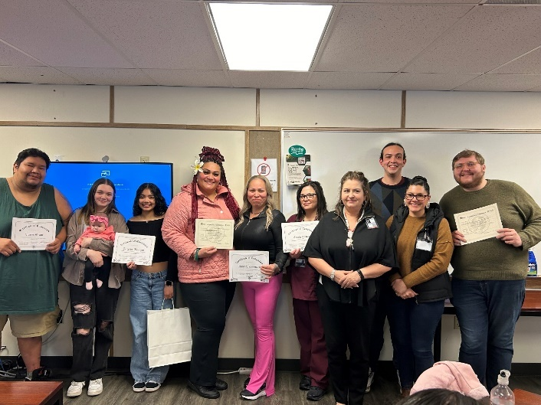
Certified Nursing Assistant Program:
- Key partners:
  - Renton Technical College
  - Muckleshoot Elders In-Home Support Services (MEIHSS)
- Program Offerings:
  - Transportation from MTC to Renton Technical College and practicum sites
  - Tuition coverage/books, scrubs, and supplies
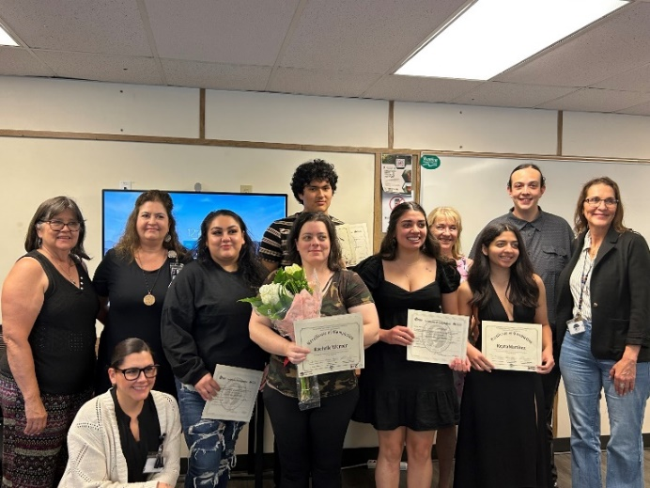
- Completion Data:
  - Winter Cohort
    - 6 graduates earned their Nursing Assistant Certification with Renton Technical College
    - 3 Muckleshoot tribal members and 3 community members
    - 5 MEIHSS employees and 1 community member
  - Spring Cohort
    - 8 enrollees, 6 graduates in spring quarter
      - 2 students will makeup practicum hours in October
    - 6 community members
    - 3 MEIHSS employees and 3 community members
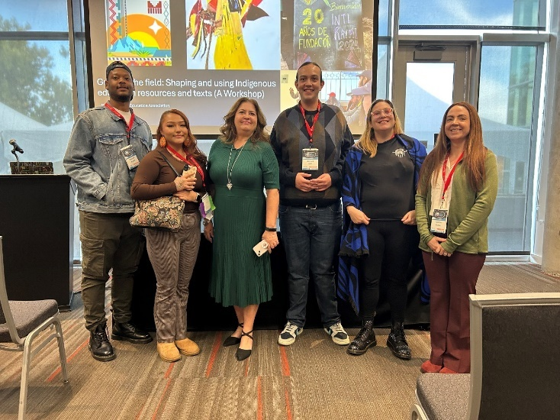
Early Childhood Education Program:
- Key partners:
  - Green River College
    - ECE Department
    - Workforce Education Office
    - Tribal Pathways Manager
  - Muckleshoot Early Childhood Education
  - Muckleshoot BOW Program
- Program offerings:
  - Place-based at Muckleshoot Tribal College
  - Light continental breakfast provided
  - Connection to funding sources for community members (Workforce office hours, FAFSA assistance, non-MIT tribal scholarships
  - Support from MIT Scholarship for enrolled tribal students
- Completion data:
  - 11 students earned their WA State ECE Initial Certificate with the cohort in the 2024-2025 school year
    - 6 Muckleshoot tribal member and 5 Muckleshoot community member graduates
    - 10 of the graduates were Muckleshoot ECE Employees
  - 13 students enrolled in 2025-2026 Initial Certificate Cohort
    - 11 Muckleshoot tribal members and 2 community members
    - 11 Muckleshoot ECE employees, 1 BOW Participant

Continuing Education Department
Continuing Education Manager: Justine.Koble@Muckleshoot.nsn.us, (253) 876-3375
Assessment and Instruction Specialist: Christopher.Miller@Muckleshoot.nsn.us, (253) 876-3395
Education Resource Specialist: Breann.Mudrick@Muckleshoot.nsnu.us, (253) 294-8186
Location: 39811 Auburn Enumclaw Rd. SE, Auburn, WA 98092

Department Description:
The Continuing Education Department serves the Muckleshoot Community by offering a range of workshops and programs for personal enrichment and educational recovery. Programming offered results in the obtainment of a high school diploma, or high school equivalency for the learner. Workshops are taught by cultural experts in their field and are offered to enrolled students and community members.

Program Description: Testing Center
The Muckleshoot Tribal College Testing Center continues to provide a full range of academic and certification testing, including placement and remote options. We remain a partner with Northwest Indian College by offering in person Accuplacer testing as well as virtual appointments. This year, we expanded our services with the Pearson IT Bundle, adding CompTIA+ and Cisco certification exams to our offerings.
Program Outcomes:
- Since, 2024 a total of 19 GED subject tests have been administered at the Muckleshoot Tribal College Testing Center.
- GED testing continues to be a core service offered for students and community members.
- Regular appointments ensure flexibility and support for student success.
Program Description: HS21+
Adult students work with an RTC instructor and the Muckleshoot Tribal College Education Resource Specialist to demonstrate competencies in reading, writing and math contextualized in science, history, government, occupational studies, and digital literacy. The program combines culturally relevant current coursework with previous learning, and work and life experiences to result in a Washington State High School Diploma. The HS21+ program empowers adult learners to take charge of their education, ensuring they are equipped with the relevant skills needed for success in their chosen fields.
- HS21+: 23 enrolled students, 16 MIT, 3 other tribally enrolled, 5 community members
- Fall 2024-Spring 2025: 26 graduates, 18 MIT
- Offers one-on-one tutoring through both scheduled appointments and drop-in sessions with an instructor.
- Partners with various MIT departments to deliver comprehensive support for Tribal Members pursuing a high school diploma.
- Delivers individualized accommodations to support students with diverse learning needs.
- Works in collaboration with Renton Technical College to offer culturally relevant pathways for earning high school credits.

Northwest Indian College – Muckleshoot Site
Site Manager: Nicole L. Cabral,
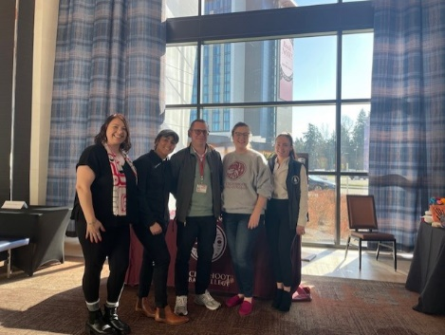
Address: 39811 Auburn Enumclaw Rd SE
Auburn WA 98092
Phone: 253-876-8176
Email: Nlcabral@nwic.edu

Overview: Northwest Indian College is honored to be part of the Muckleshoot community.
The College offers a variety of educational programs to meet the academic, vocational, and cultural needs of the Muckleshoot people and community. The NWIC Muckleshoot Extended Campus brings those programs conveniently into the community.
At NWIC, Muckleshoot, students are encouraged to develop themselves and discover ways to contribute to their communities and families. They learn ways to understand and support the goals of the Muckleshoot Indian Tribe, especially in the areas of self-governance, as well as social and economic well-being.
Degrees Offered:
(Classes offered in Person at Muckleshoot Tribal College, via Zoom, and online/Independent):
- Associate of Arts and Sciences (2 year degrees)
- Business and Entrepreneurship
- General Direct Transfer
- Public and Tribal Administration
- Associate of Applied Science Transfer
- Early Childhood Education
- Associate of Technical Arts
- Chemical Dependency Studies
- Bachelor of Arts (4 year degrees)
- Community Advocates and Responsive Education in Human Services
- Native Studies Leadership
- Tribal Governance and Business Management
- Bachelor of Science
- Native Environmental Science

Effective Teaching Institute
The Effective Teaching Institute for Native Learners originated with Dr. Willard Bill Sr. and Jim Egawa in the 1980’s. The leadership of this work was then passed on to Dr. Denise Bill and Madrienne White. Although its format and content have evolved over the years the basic concept of engaging in effective practices for Native students is the core of this work.
- 271 educators registered to attend June 24-26, 2025.
- Event was hosted in the Muckleshoot Casino Events Center.
- Hosted in collaboration with Muckleshoot Tribal School, who provided 18 educator clock hours.
- Daily workshops included “Muckleshoot Mornings” where educators could learn more about Muckleshoot history, culture, and language.
- 92% of surveyed attendees reported a high level of enjoyment from ETI’s offerings.
- This year, the conference expanded its workshop offerings from two grade-specific strands to three interdisciplinary strands, providing a more integrated and collaborative learning experience for attendees.

